**Python**

Use two asterisks and a question mark like np.*load*? To get an overview of all functions that contain that word:

If you have a = [1, 2, 3] and then write b = a, then you are not *copying* a to b, but *creating a second reference* to [1, 2, 3]. Like here:

Use isinstance(a, int) to check whether an object is of a specific object type:

Use iter() to check whether an object is iterable (e.g. you can perform a loop on it):

**Importing parts of a module**

**Binary operations**

**Note that == is not the same as is**

Take a = 2, b = a, and c = list(a). Both a == b and a == c will return True, because all of the objects are equal to value 2. But only a is b will return True, because b refers to a and is not a *separate copy* like c. The list() function always creates a separate copy (a new list).

**Python scalar types (data types)**

None, str, bytes, float, bool, int

**Working with dates**

Use from datetime to import types like datetime, date or time.

Use datetime() to create a date with time:

Use date() to return date and time() to return time:

The strftime method formats a datetime as a string:

**Replace parts of dates with 0, e.g. minutes and/or seconds:**

**for loops with continue and break**

Use continue to continue the iteration (skip the value)

To stop the iteration use break:

The break keyword only terminates the innermost for loop; any outer for loops will continue to run:

A while loop:

Use pass in a loop in blocks where no action is to be taken:

**Built-In Data Structures, Functions, and Files**

Tuple, list, and dictionary are some of the most frequently used sequence types.

**Tuples**

If you have a tuple like values = 1, 2, 3, 4, 5 and want to assign only the first two values a name and other values are not important you can make use of *rest or *_. Name after asterisk can be rest or _ or anything else.

Count the number of occurrences in a tuple using a.count():

**Lists**

The list() function can be used to materialize an iterator or a generator:

**List concatenation** can be done using + or .extend(). Using .extend() is preferable due to computational efficiency.

**Slicing in Python example:**

Use [::2] to select every second value or [::-1] to inverse a list:

**Dictionary**

Use .pop to delete a value in a dictionary and return it as a variable:

Use functions .keys(), .values(), and .items() to iterate (or select) over keys, values, and both keys & values in a dictionary:

Update a dictionary using .update():

Iterating over a dictionary (create a dictionary from two lists):

Create a dictionary from a dict():

**To sort a list of values by e.g. its first letter:**

Option 1: Option 2 (preferred):

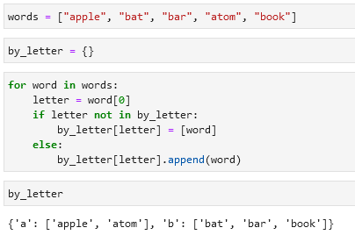

Or option 3 (preferred):

**Valid keys and values in dictionaries**

* Values can be any Python object.
* Keys have to be immutable objects like scalar types (int, float, string) or tuples (all the objects in the tuple need to be immutable).

To check whether a value can be used as a key use hash() (check for hashability):

**Set**

A set is an unordered collection of unique elements.

Two ways to create a set:

Set operations:

**Sequence functions**

**Enumerate**

**zip**

zip “pairs” up the elements of a number of lists, tuples, or other sequences to create a list of tuples:

The number of elements it produces is determined by the shortest sequence:

A common use of zip() is simultaneously iterating over multiple sequences:

**reversed**

Iterates over the elements of a sequence in reverse order:

**List, Set, and Dictionary Comprehensions**



=

**Example of a list comprehension:**

**Dictionary comprehension:**

**Set comprehension:**



Alternative to set comprehension is the map() function:

**Dictionary comprehension:**

**Nested list comprehension:**

Example 1:

Example 2:

**Functions**

Example of a function:

**Cleaning text in a list:**

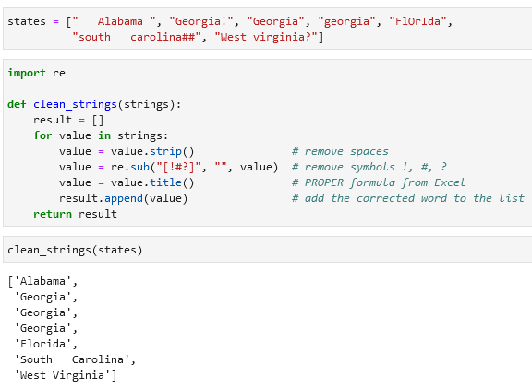re, .strip(), .sub(), .title()

**Lambda functions**

**Generators**

Generator example:

yield

**Generator expressions**

**intertools module**

Example with a intertools.groupby() function:

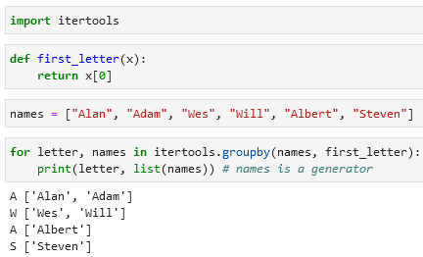

Some useful functions from the itertools module:

chain(*iterables), combinations(iterable, k), permutations(iterable, k), groupby(iterable[,keyfunc]), product(*iterables, repeat = 1)

**Files and the operating system**

Open a file:

Two possibilities to close a file:

